**Boyle, Kay (1902-1992)**

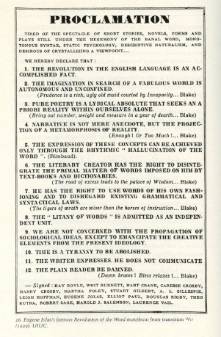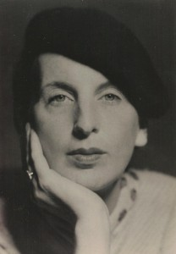Kay Boyle was a novelist, short story writer, poet, essayist and political activist. Born in St Paul, Minnesota, she married a Frenchman, Richard Brault, in 1922, and moved to France with him the following year. She then lived in Europe for most of the next twenty years, and her early novels frequently reflect her own experiences as an expatriate. Languid and impressionistic in style, her early prose work focuses on relationships between men and women. In later life she also became heavily involved in politics and her work took on a more urgent social tenor; for example, the 1936 novel *Death of a Man* alerted readers to the threat of Nazism. Boyle remained a vigorous political campaigner throughout her life. She was most celebrated in her lifetime for her short stories, and won the O. Henry prize in 1935, for ‘The White Horses of Vienna’, and in 1941, for ‘Defeat’. Her best known work is *Being Geniuses Together*; begun by the author and publisher Robert McAlmon in 1934, Boyle revised and added alternate chapters after McAlmon’s death. The book chronicles the literary and artistic milieu of Paris in the 1920s, in which Boyle was a central figure.

Boyle was a signatory to the radical ‘Revolution of the Word’ manifesto, published in 1929 in the avant-garde literary journal *transition* to which she was a regular contributor.

url: <http://clayandres.blogspot.co.uk/2010/12/transition-manifesto-or-i-like-idealism.html>

This item might be better as a pop-out so that it can be large enough for the type to be legible.

Kay Boyle photographed by Man Ray in 1931.

url: <http://www.angryfilmmaker.com/dangerous-kay-boyle/kay-boyle-photos/kay-man-ray-photo-1931/>

**A recording of Kay Boyle reading from her work, followed by an interview, on the occasion of her 86th birthday.**

I couldn’t save this as an audio file; the url is: <http://archive.org/details/AM_1985_02_19>

**Selected list of works**

*Process* (1924; first published 2001)

*Short Stories* (1929)

*Wedding Day and Other Stories* (1930)

*Plagued by the Nightingale* (1931)

*Year Before Last* (1932)

*My Next Bride* (1934)

*Death of a Man* (1936)

*Primer for Combat* (1942)

*Avalanche* (1944)

*A Frenchman Must Die* (1946)

*The Smokinq Mountain: Stories of Germany During the Occupation* (1951)

*Generation Without Farewell* (1960)

*Being Geniuses Together* (1966)

*The Underground Woman* (1975)

**Further reading**

Austenfeld, Thomas Carl (ed.) (2008) *Kay Boyle for the twenty-first* century: new essays, Trier, Wissenschaftlicher Verlag Trier.

Elkins, Marilyn (ed.) (1993), *Metamorphosizing the Novel: Kay Boyle's Narrative Innovations*, New York: Peter Lang.

Elkins, Marilyn (ed.) (1997) *Critical Essays on Kay Boyle*, New York: G. K. Hall.

Mellen, Joan (1994) *Kay Boyle: Author of Herself*, New York: Farrar, Straus & Giroux.

Spanier, Sandra Whipple (1986) *Kay Boyle: Artist and Activist*, Carbondale: Southern Illinois University Press.

Bryony Randall, University of Glasgow